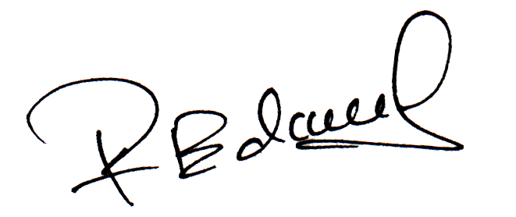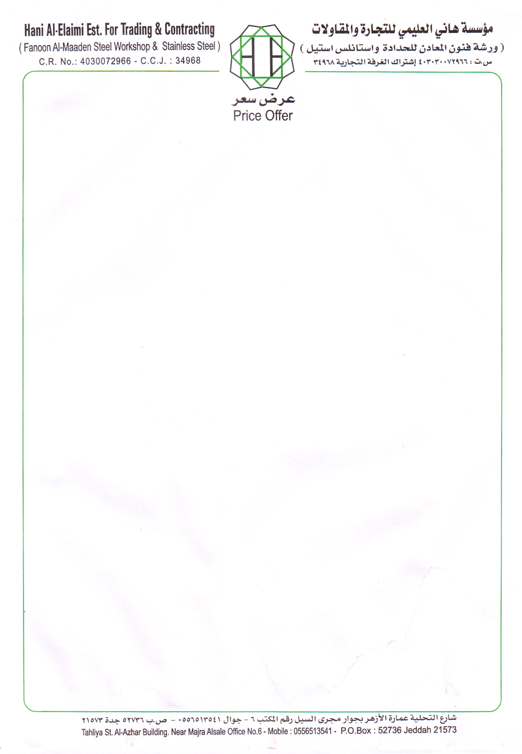

No. 3734

Dated: <To2>

**TO WHOM IT MAY CONCERN**

This is to certify that Mr. <Name> S/O <fname> has worked with this Organization as a <Designation> from <From2> to <To2>.

During the period of his employment with the company his performance, throughout this tenure was satisfactory and we found him to be a dedicated member of our Organization.

We wish him all the success in his future endeavors

**ASIF GETI**

**ACTING GENERAL MANAGER**